1. 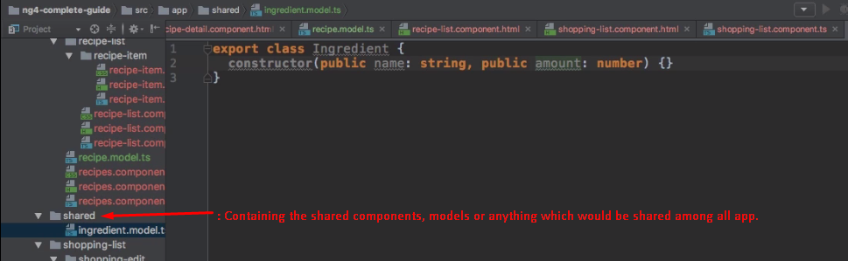
2. **NOTE**: The above shared folder is under **src/app** folder.